Bug Number | 1
Title | Product Names Do Not Translate When Switching Site Language
Severity | Medium
Priority | High
Steps to Reproduce | - Open the website: https://practicesoftwaretesting.com/.  - In the top-right corner, open the language selector.  - Change language from EN to FR, DE, or ES (any other supported language).  - Observe the product list on the homepage or category listing page.
Actual | Product titles and descriptions remain in English, e.g., "Pliers", "Combination Pliers", "Bolt Cutters".
Expected Results | Entire page content should reflect the chosen Language.
Root cause | Product data may be stored in a static English-only dataset with no localized fields in the database.
Screenshot | 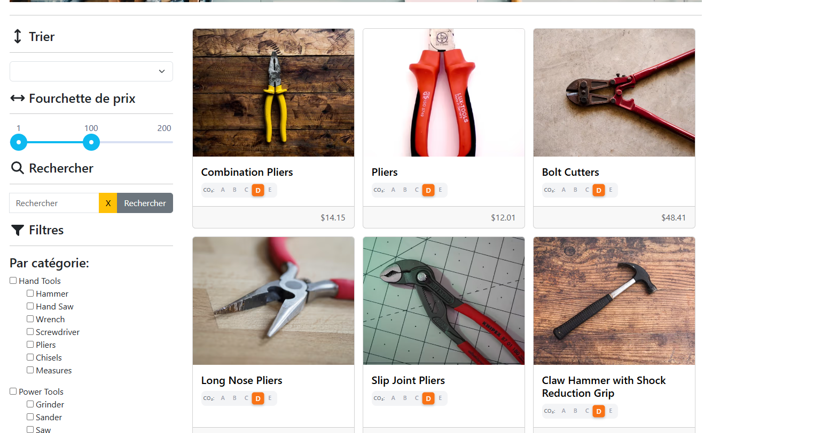

Bug Number | 2
Title | System Allows Multiple Customer Registrations Using the Same Data
Severity | High
Priority | High
Steps to Reproduce | - Navigate to https://practicesoftwaretesting.com/.  - Go to Customer Registration page.  - Enter valid customer details (Name, Email, Password, Address, etc.).  - Submit the registration form.  - Go back to the Customer Registration page.  - Enter the exact same details, especially the same email address.  - Submit the form again.
Actual | The system successfully creates a new customer account, even though the same email and user details already exist.
Expected Results | The system should prevent registration using an already registered email.
Root cause | Backend validation for unique email constraint is missing.
Screenshot

Bug Number | 3
Title | Product Descriptions Display Latin Placeholder Text and Do Not Change With Selected Language
Severity | Medium
Priority | High
Steps to Reproduce | - Open the website: https://practicesoftwaretesting.com/  - On the top-right corner, open the language dropdown.  - Change the language from EN to FR, DE, or ES.  - Navigate to any product card or open any product details page.  - Observe the product description text.
Actual | Product descriptions appear as Latin placeholder text
Expected Results | Product descriptions should appear as meaningful translated text in the selected language.
Root cause | No localization fields exist for product descriptions
Screenshot | 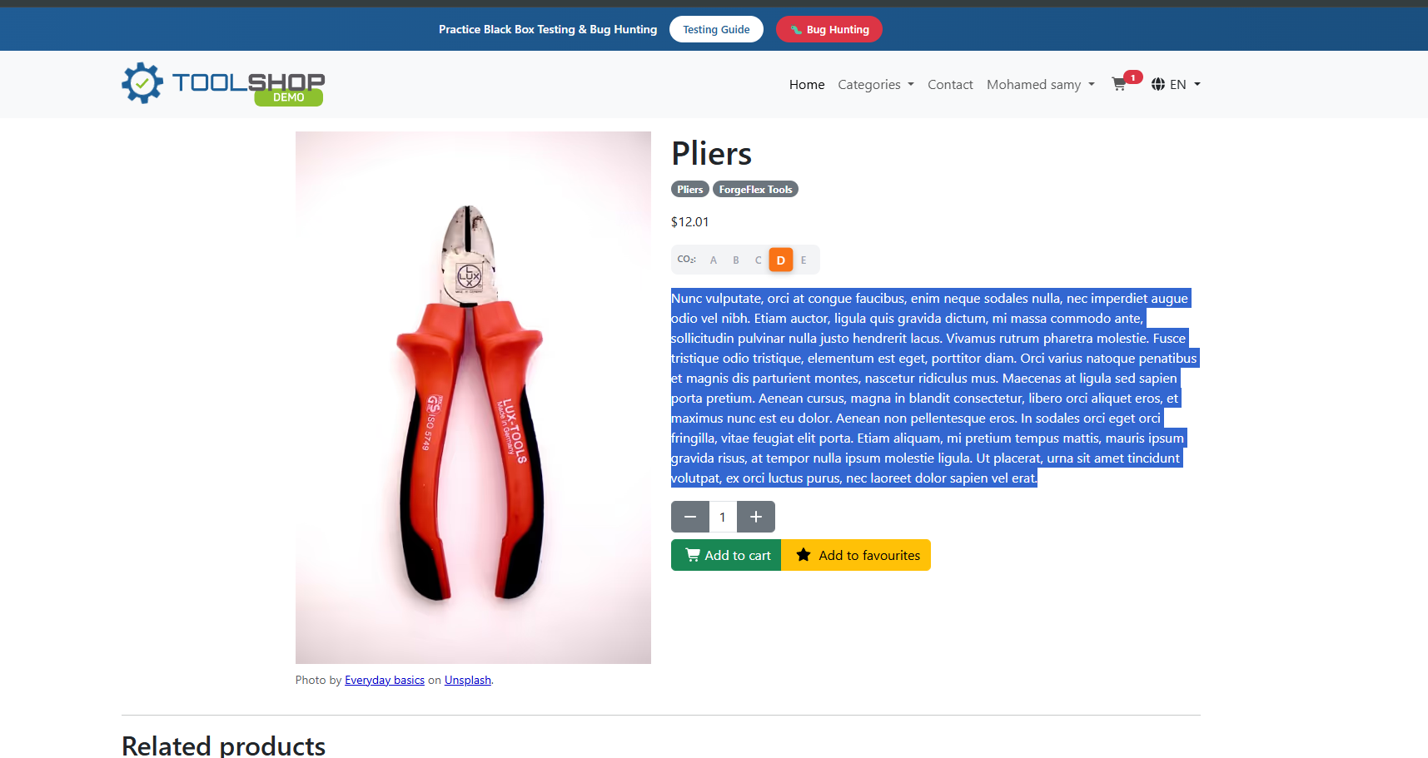

Bug Number | 4
Title | “Add to Favorite” Returns Unauthorized Error for Logged-In Users
Severity | High
Priority | Critical
Steps to Reproduce | - Open https://practicesoftwaretesting.com/.  - Log in with a valid customer account.  - Navigate to any product listing or product details page.  - Click the heart icon / Add to Favorite.  - Observe the system behavior.
Actual | The system returns “Unauthorized” (401 error).
Expected Results | The system should confirm: “Product added to favorites.”
Root cause | Session token may not be saved in cookies/localStorage on login.
Screenshot | 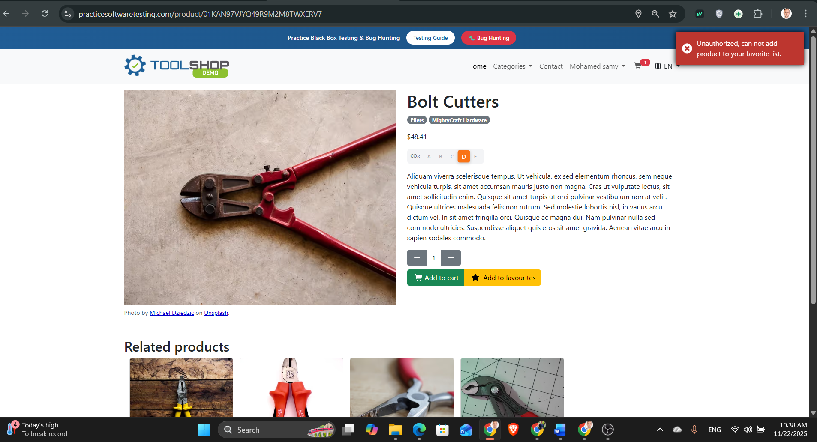
 | 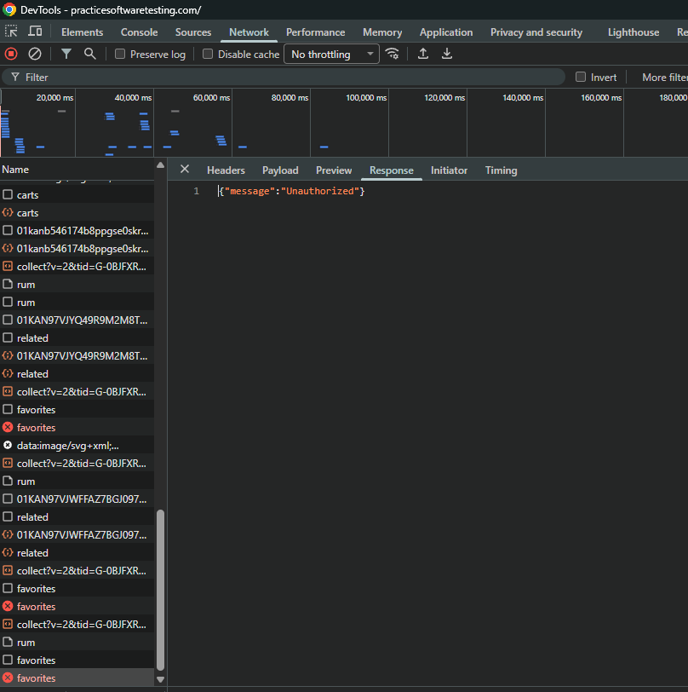

Bug Number | 5
Title | Product Image Cut / Not Displayed Properly
Severity | Medium
Priority | Low
Steps to Reproduce | - Open https://practicesoftwaretesting.com/.  - Scroll down to the product listing section.  - Observe the product cards, such as the item “Pliers”.
Actual | The product image is partially cut, showing only the lower half of the tool.
Expected Results | The product image should be displayed fully and proportionally, without cutting critical parts of the item.
Root cause | Image container uses fixed height without maintaining aspect ratio.
Screenshot | 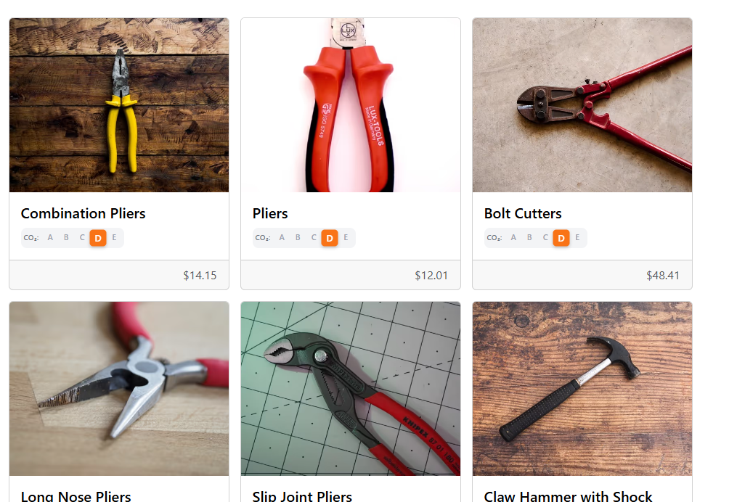

Bug Number | 6
Title | Invoice date less than 2 hours to current time
Severity | Low
Priority | Low
Steps to Reproduce | - Log in to the website.  - Select any item.  - Add the item to the cart.  - Go to the cart and complete the shopping process.  - Proceed to checkout and finalize the purchase.  - Open the "My Invoices" page.  - Select the correct invoice from the list.
Actual | The invoice date shows a time that is less than 2 hours from the current system time.
Expected Results | The invoice date should reflect the exact creation time of the invoice accurately, matching the current time at checkout
Root cause | Possible delay in updating the invoice timestamp, or a server-client timezone mismatch.
Screenshot | 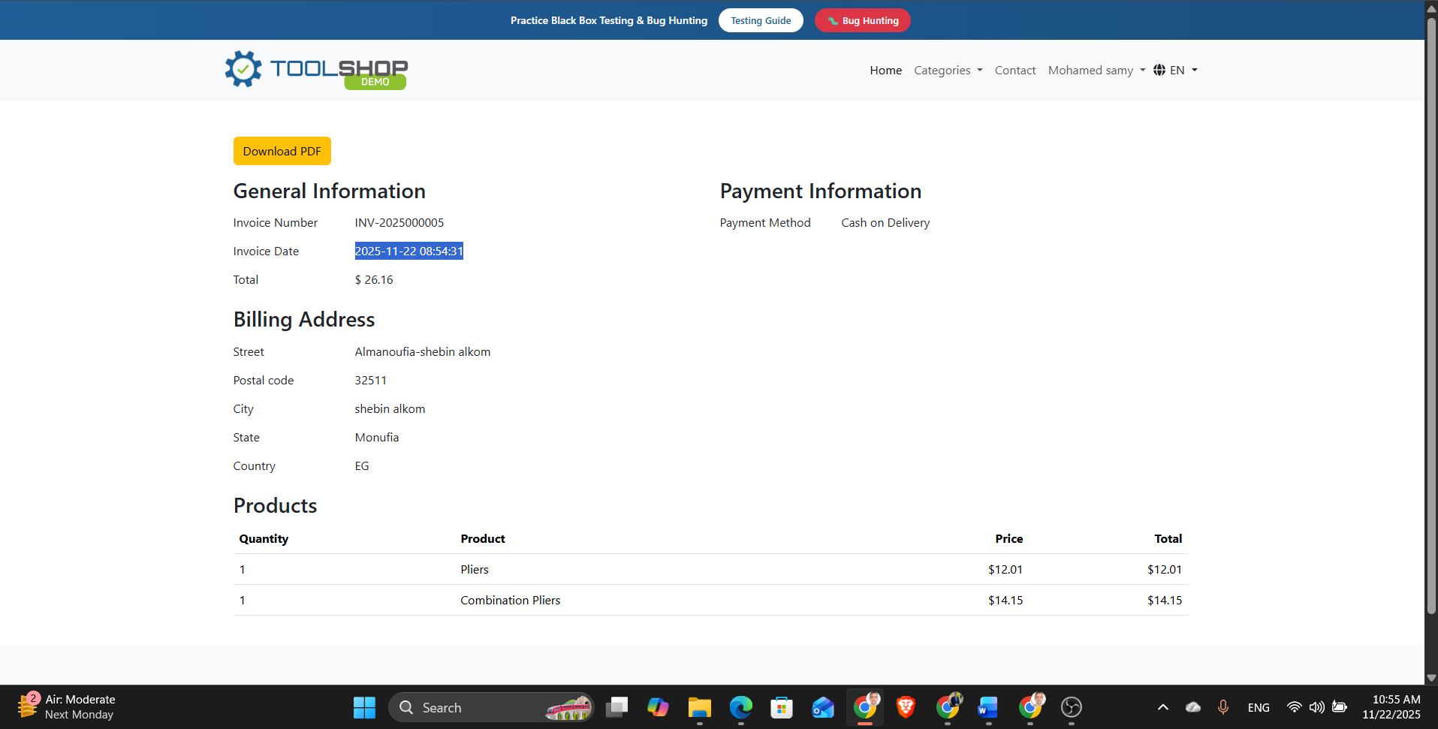

Bug Number | 7
Title | The "Download PDF" button takes several seconds before it becomes clickable
Severity | Medium
Priority | Medium
Steps to Reproduce | - Log in to the website.  - Complete a purchase and navigate to "My Invoices" page.  - Select an invoice.  - Attempt to click the "Download PDF" button.
Actual | "Download PDF" button takes several seconds before it becomes clickable, causing a delay in downloading the invoice.
Expected Results | The "Download PDF" button should be immediately clickable after the invoice page loads
Root cause | Likely a JavaScript load delay or backend processing time before enabling the button.
Screenshot | 